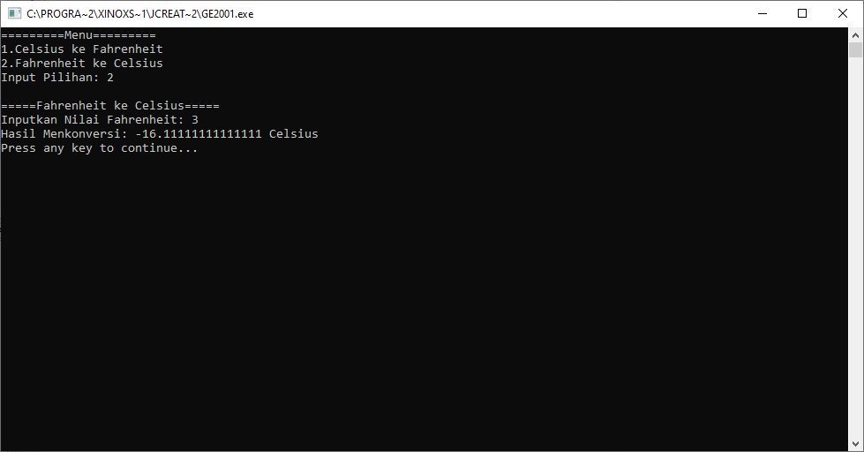HADIAH PRAKTIKUM 1

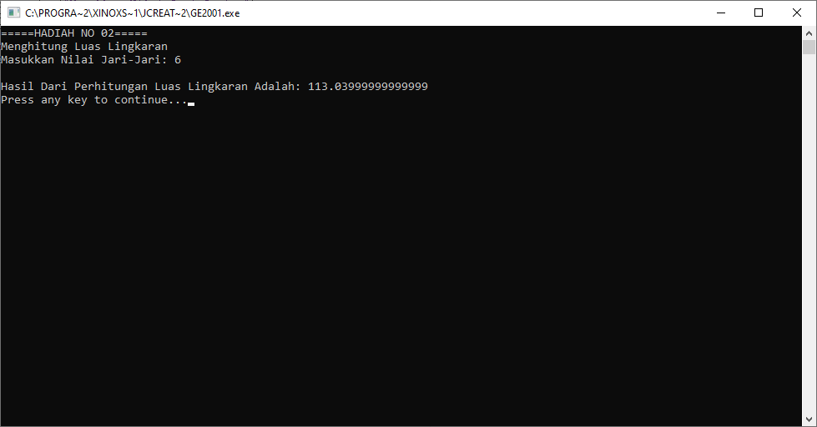HADIAH PRAKTIKUM 2